**E-Portfolio Task Week 2 – Evidence of creating a pull request**

The Repo in question (<https://github.com/Pajmage/Eportfolio_Task>) has 2 branches: main and Code. The code branch contains Python code and the main branch contains written reports.

The following is evidence of creating a pull request to merge both branches together.

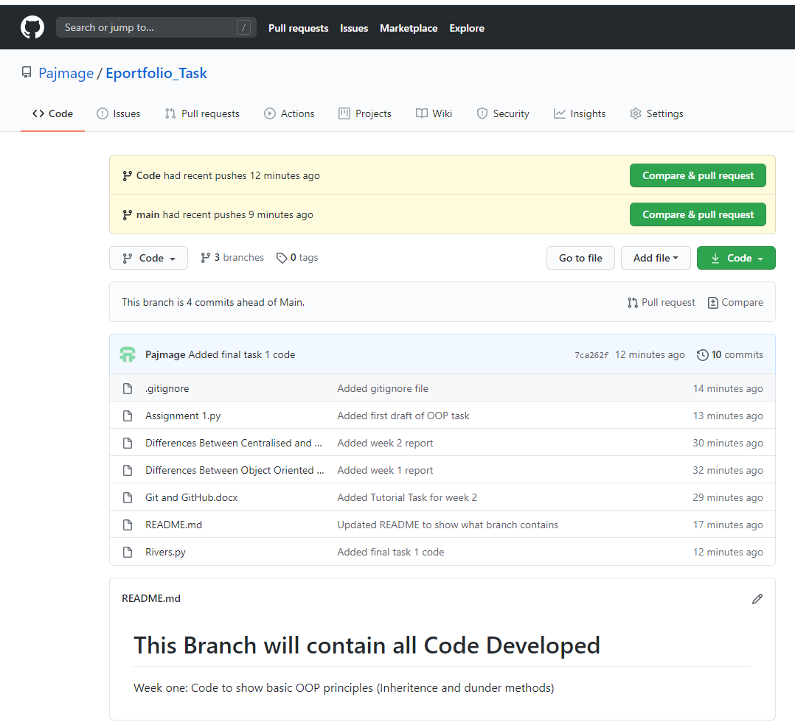Step 1: Evidence of both branches

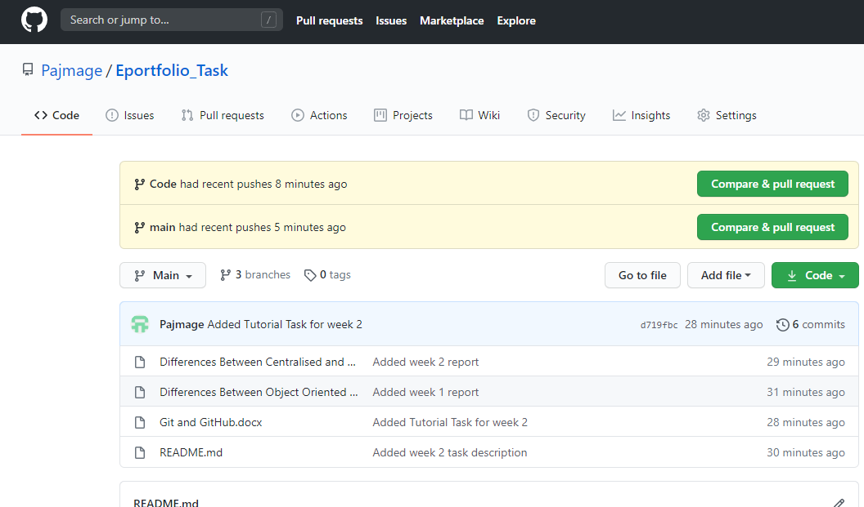

Step 2: Creating the Pull Request

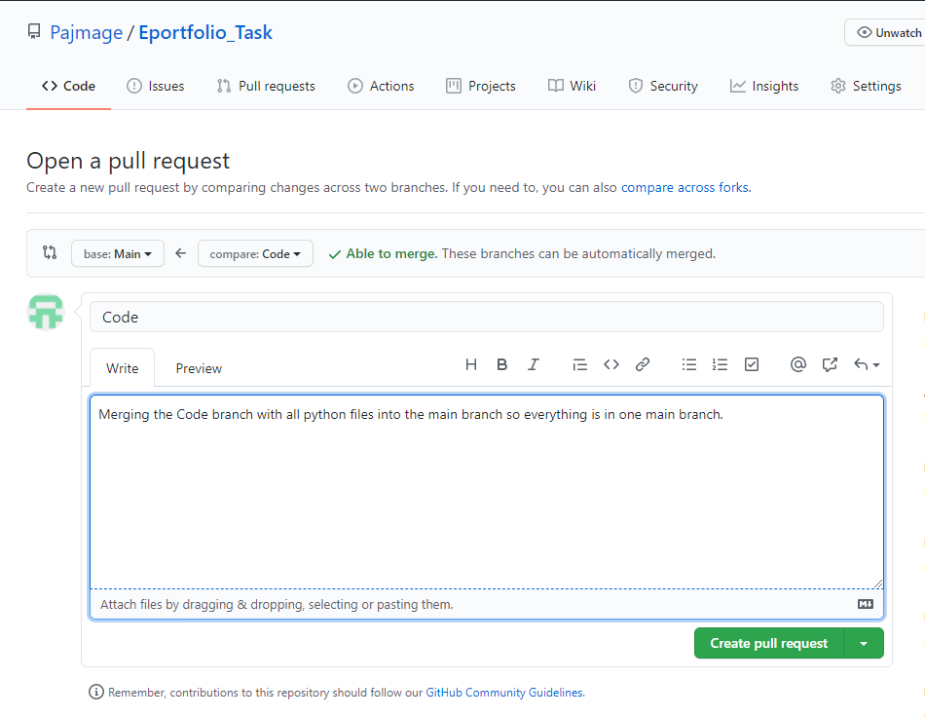  
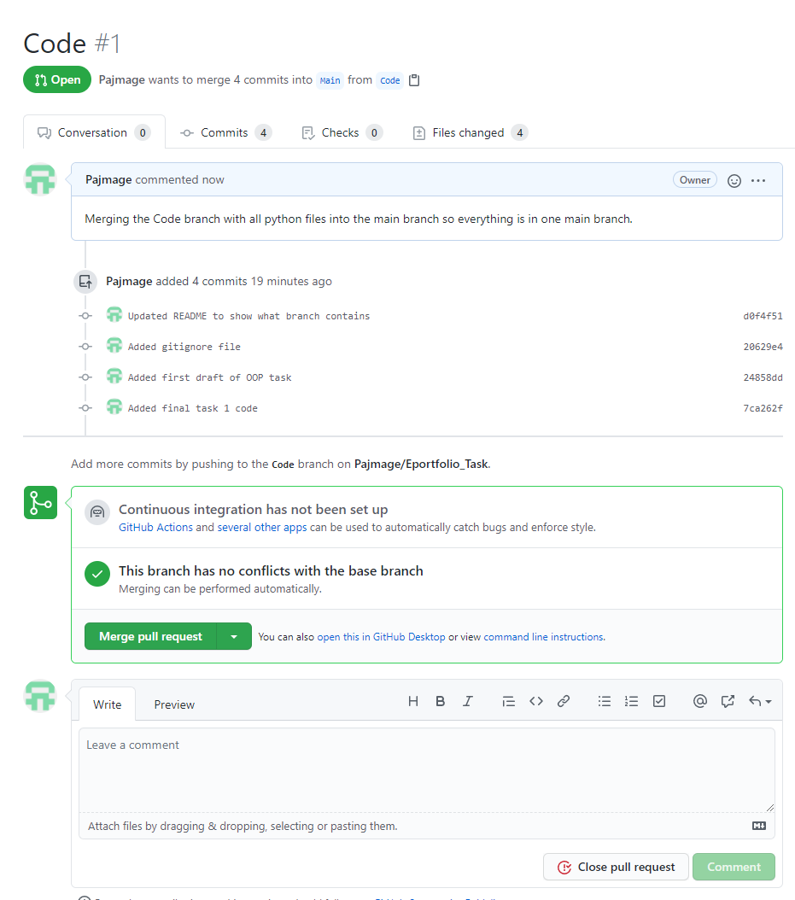

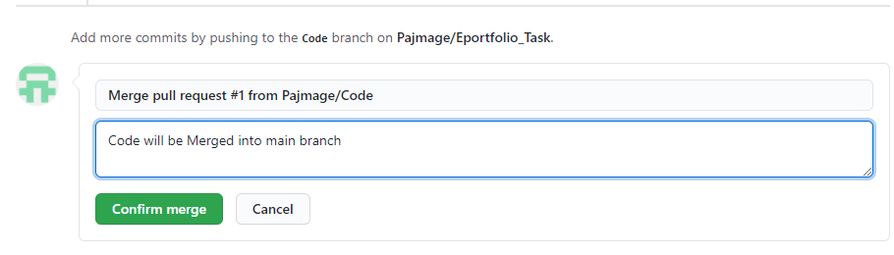

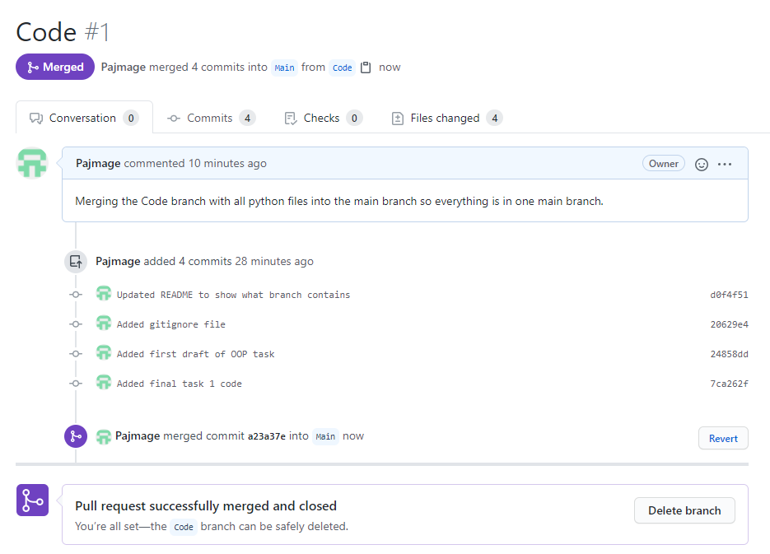

Pull request was successful.

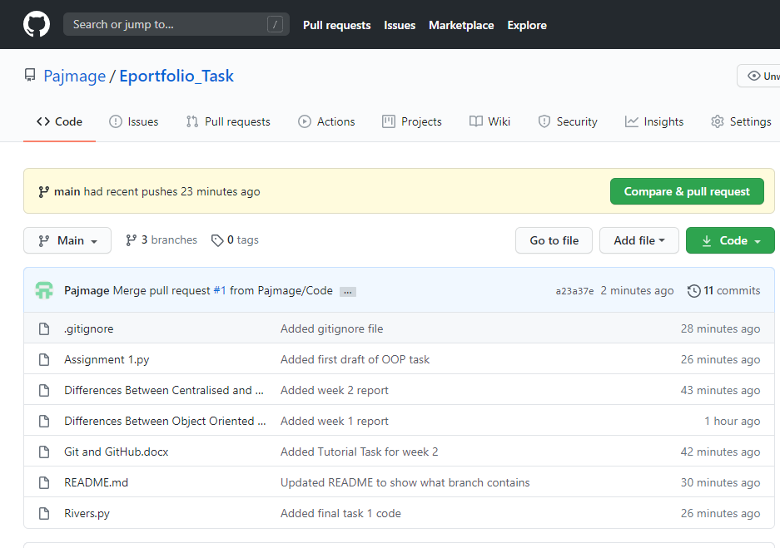

The main branch now has merged files from the Code branch.